CS 573 Advanced Software Engineering

Midterm Exam

1. Discuss when demanding precondition design and tolerant precondition design are appropriate, respectively? (15 points)

2.
a) Given two conditions x>=0 and x>0, which one is stronger? (5 points)
b) Suppose class B is a subclass of A. It overrides method m. In class A, the precondition and postcondition of m are x>0 and y>10, respectively. In class B, the precondition and postcondition of m are p and q, respectively. According to subcontracting of inheritance, discuss what p and q are appropriate. (15 points)
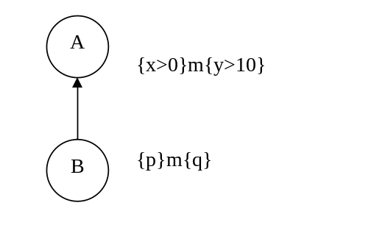
3. What is the main difference between a priori scheme and a posteriori error
scheme for dealing with abnormal cases of class design? (15 points)

4. What is the commonality of all SOLID principles (10 points)?

5. Discuss why a violation of LSP is often a violation of OCP (15 points).

6. Discuss how LSP is related to subcontracting of inheritance and explain why (10 points).

7. Given the following method and its mutant. Discuss the fault detection condition that must be satisfied by any test case in order to kill the mutant (15 points).

boolean isLeapYear(int year){
return (year % 4 == 0 && year % 100 != 0) || (year % 400 == 0);
}

boolean isLeapYear(int year){
return (year % 4 == 0);
}

